**Lab manual 5!**

**Repetition Statement (while loop)**

**Learning Objectives:**

The objective of this exercise is to make you familiar with the repetition statement

**while**

repetition statement.

**Introduction:**

A while loop statement repeatedly executes a target statement as long as a given condition is true.

**Syntax:**

**initialization**

**while(condition){**

**statement;**

**inc/dec;**

**}**

**Example 1:**

Write a C++ program print all natural numbers from 1 to n using while loop.

**Code:**

#include <iostream> using namespace std;

/* function main begins program execution */ int main( void )

{

int i=1, end=10;

cout<<"All natural numbers from 1 to 10 are:\n";

/* Print natural numbers from 1 to end */ while(i<=end)

{

cout<<i<<endl;

i++;

}

return 0; /* indicate that program ended successfully */

} /* end function main */

**Task 1:**

Write a C ++ program to print sum of all odd number between 1 to 100 using while loop.

**Input :**

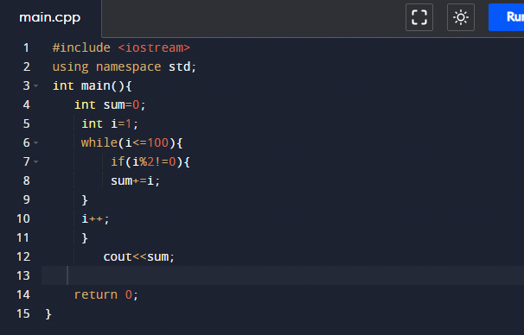

**Output :**

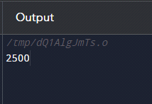

**Task 2:**

Write a C++ program to print multiplication table of any number using while loop.

**Input :**

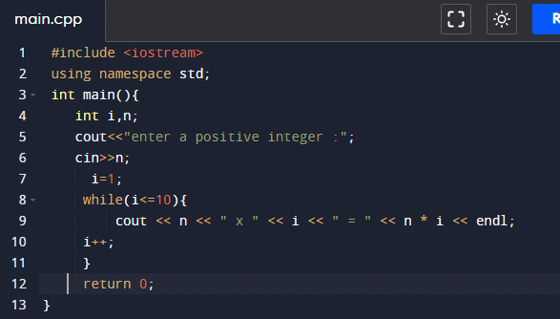

**Output :**

